Install Node.JS

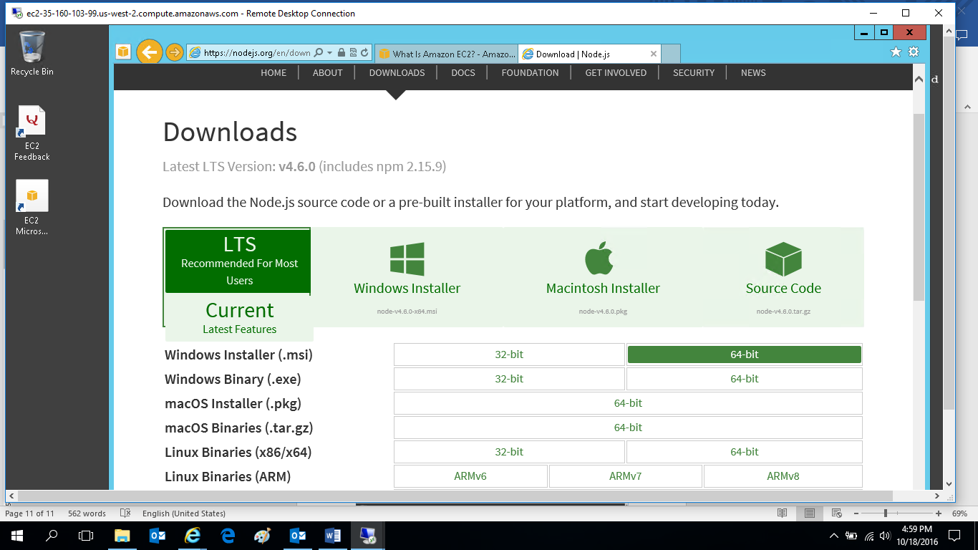

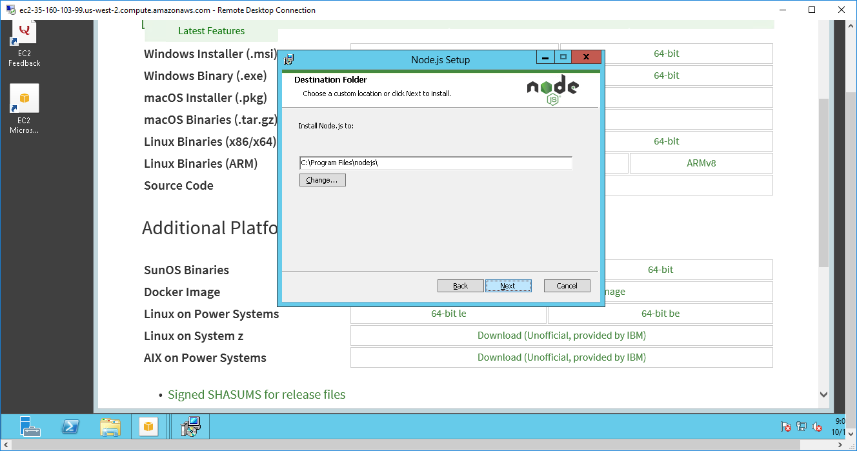

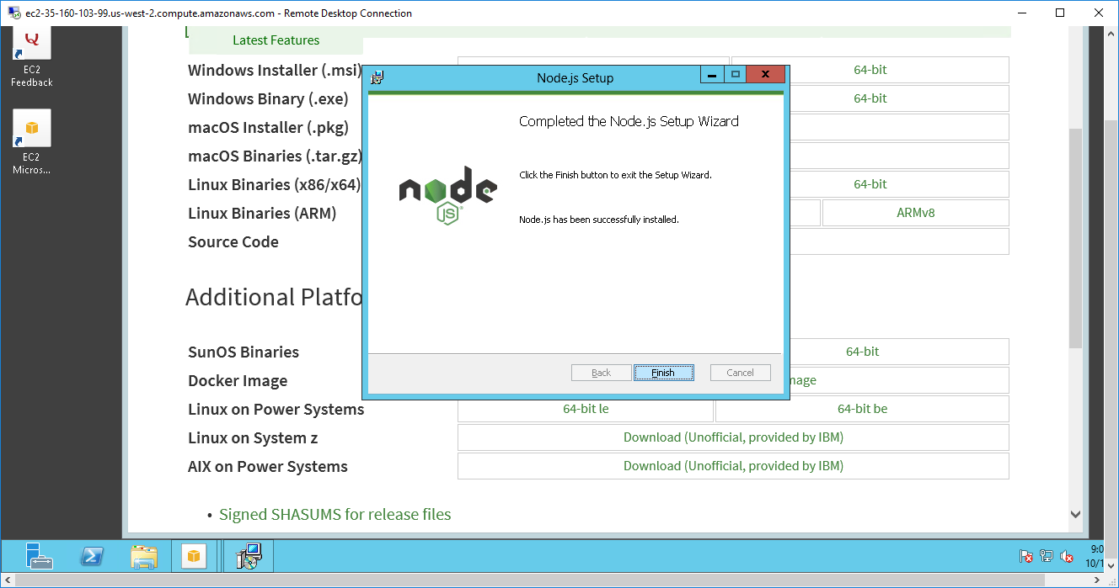

Node.Js Server testing

Once installed, nodejs folder will be created in c:\program files

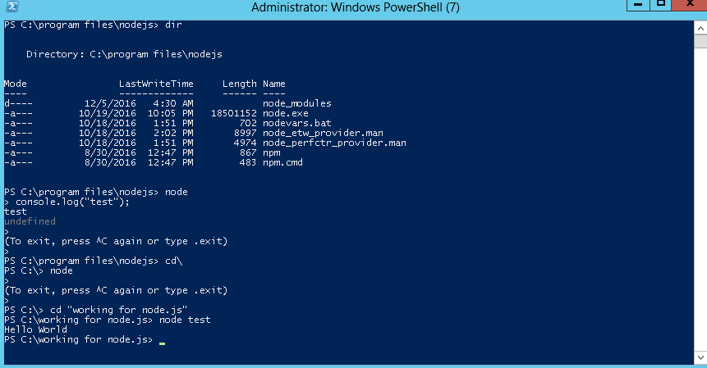

Note: a test.js file containing only one statement

Console.log(“Hello World”);

is created in c:\working for node.js folder

then, modify the test.js and re-execute again, port number shown

// include the http module

var http = require('http');

// create a webserver

http.createServer(function (req, res) {

// respond to any incoming http request

res.writeHead(200, {'Content-Type': 'text/plain'});

res.end('Hello World\n');

}).listen(1337, '127.0.0.1');

// log what that we started listening on localhost:1337

console.log('Server running at 127.0.0.1:1337');

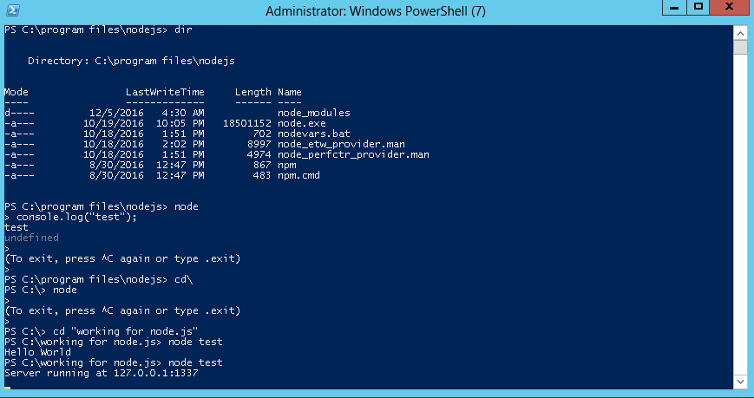

Open browser and type the web server address to check if the server is responding

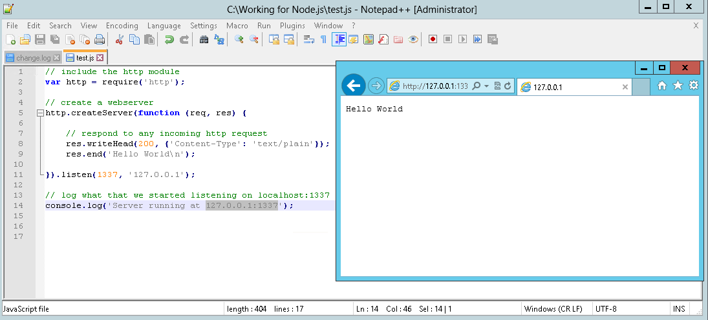

Exit the node by pressing CTL-C

Go to the working folder and type “npm install express”

NPM will be installed in the working folder

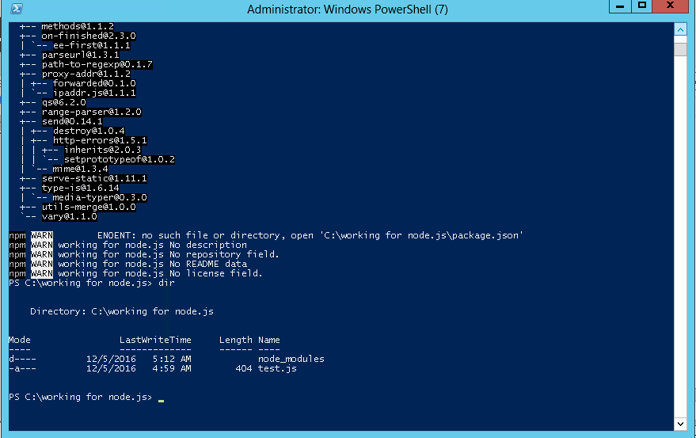

After install, a new npm node module folder will be added into the working folder

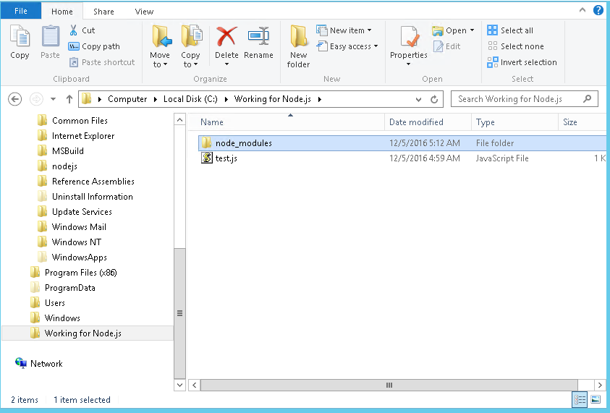

Now modify the test.js

var express = require('express');

var app = express.createServer();

app.get('/', function(req, res){

res.send('Hello World');

});

app.listen(1337);

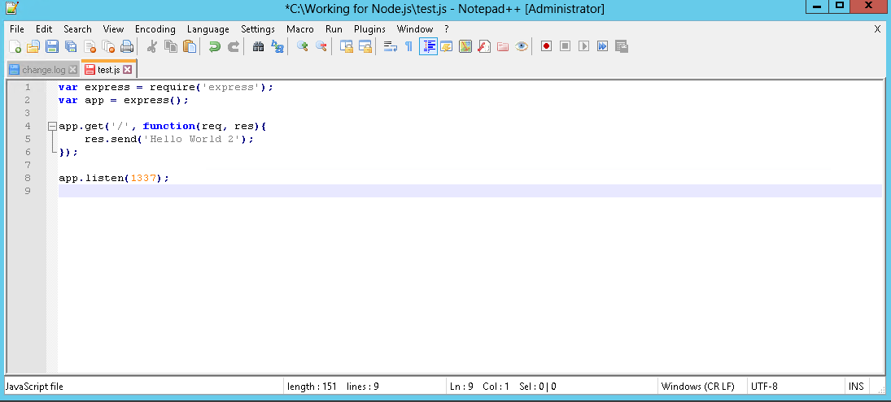

Save and rerun it

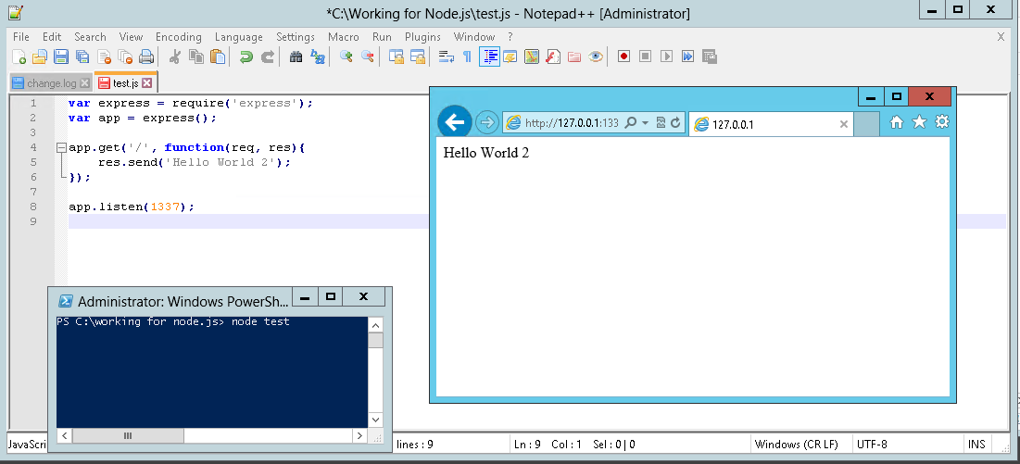

Reference link

<http://blog.gvm-it.eu/post/20404719601/getting-started-with-nodejs-on-windows>

Node.js commands 7.2.0

<https://nodejs.org/api/cli.html>

